There have been a lot of debate on how effective the ESRB ratings are on video games. Some argue that most games do not reflect the proper ratings. A study showed there were significant differences between the types and degrees of content found within T-rated games compared with E-rated games. They concluded there should be age-based rating symbols within each rating to better explain content as the initial ratings covers too wide a spectrum. [1]

How about the impact of reviews on game purchases? Reviews plays a huge role in getting popularity through ‘word-of-mouth’. However., a direct correlation between game reviews and sales was hard to determine since opinions differ quite a lot based upon the enthusiasm of the reviewer and the targeted gaming audience. A distinction was found on how scores were viewed by casual and hardcore gamers alike. [2]

**Breakdown of U.S. Computer and Video Game Sales in 2011, by Rating** [3]

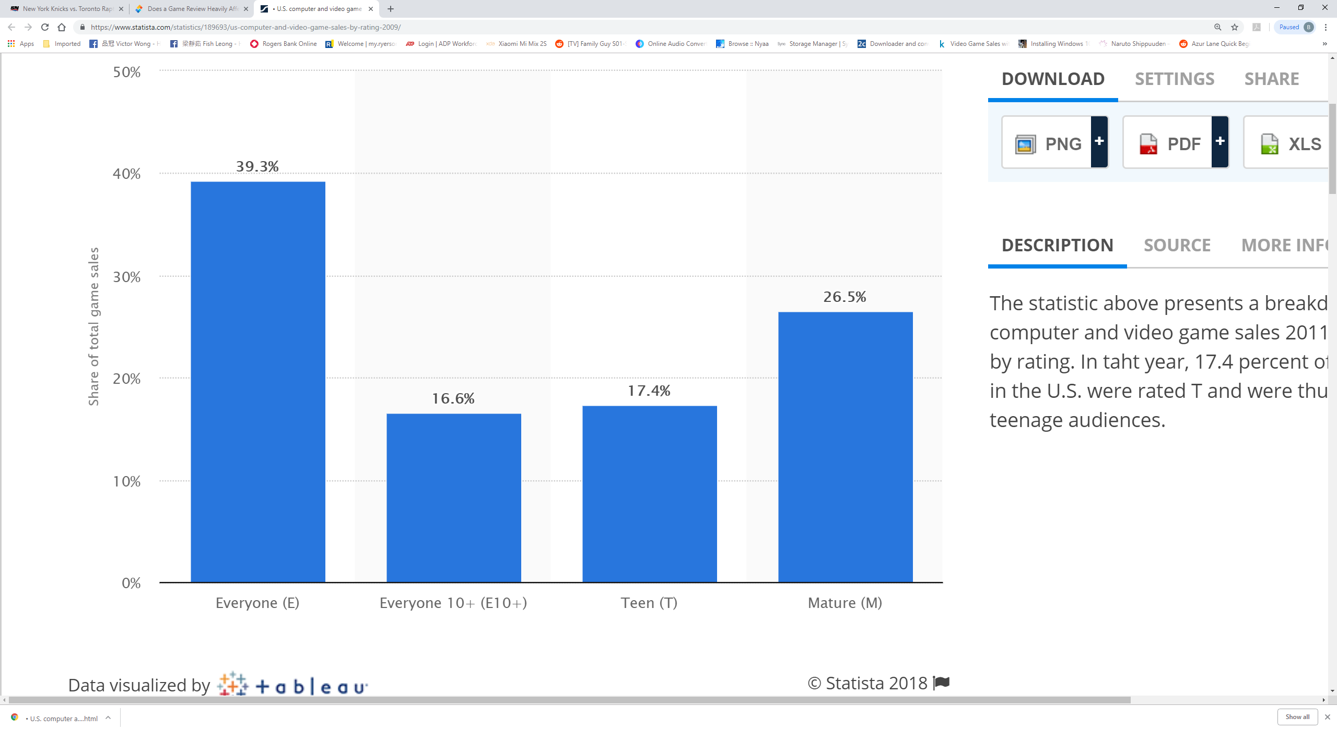

Below is a bar plot generated from our dataset using R on the distribution of games by ratings after cleaning all missing values.

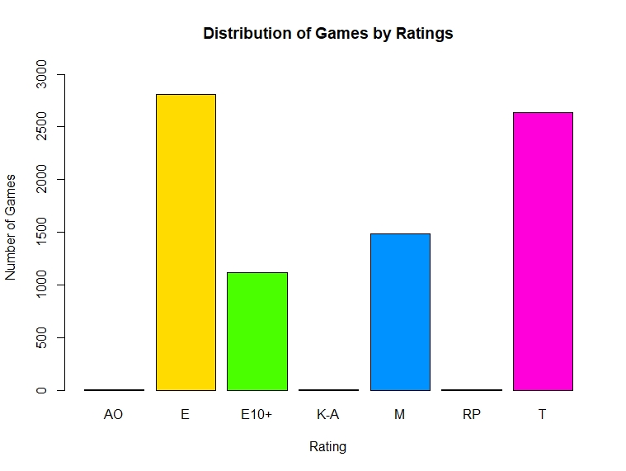

Another study was done on the impact of player experiences due to negative game reviews and user comments. Their result suggested that reading a positive review does not necessarily provide any benefits in player experience, but if it was well received then it could generate hype which in turn would lead to better sales. The report surmised negative affective text in reviews had a greater overall effect on experience over positive affective text. [4]

# References:

[1] Kevin Haninger, Kimberly M. Thompson, ScD " **Content and Ratings of Teen-Rated Video Games**" 18 February 2004.

<https://jamanetwork.com/journals/jama/fullarticle/198217>

[2] Blog Article from Social App Support, adish Co. Ltd. "**Does a Game Review Heavily Affect Game Purchases?**" 3 September 2018.

<https://socialappsupport.com/en/blog/game-review-affect-game-purchases/>

[3] Statista: The Statistics Portal," **Breakdown of U.S. computer and video game sales in 2011, by rating**"

<https://www.statista.com/statistics/189693/us-computer-and-video-game-sales-by-rating-2009/>

[4] Ian J. Livingston, Lennart Nacke, Regan L. Mandryk "**The Impact of Negative Game Reviews and User Comments on Player Experience**" August 2011.

<https://www.researchgate.net/publication/228466586_The_Impact_of_Negative_Game_Reviews_and_User_Comments_on_Player_Experience>